Dear Members and Supporters

NORTH DERBYSHIRE CONSERVATIVES’ CHRISTMAS PARTY:
Join us for mulled wine, mince pies and an update from Lee Rowley MP

7.30pm | Friday 7th December 2018 | Bassett Rooms, Church Street, Ashover, S45 0AD

As we draw nearer to the close of what has been an extremely busy year for the Association, I am delighted to invite you to our Christmas Party in Ashover on 7th December.

It should be a great opportunity to catch up with old friends (and meet new ones) in an informal setting over mulled wine and mince pies. Our MP for North East Derbyshire, Lee Rowley, will be in attendance and will give a short talk reflecting on what’s been happening in British politics in 2018 and what his hopes are for the year ahead. We’ll also be running a very special Christmas-themed raffle and any prizes you’d like to bring and donate on the night will be very gratefully received.

Tickets are just £5 each and any proceeds will go towards our fighting fund for next year’s District and Borough elections in Bolsover, Chesterfield and North East Derbyshire, where 138 council seats will be up for grabs!

To book your place, please complete the tear-off booking form below and return in the freepost envelope provided.

We hope that you’ll support this great event and look forward to seeing you there.

Yours sincerely,
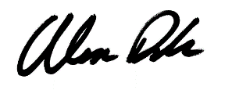

Alex Dale
Association Chairman

